
Getting Started Guide
Chapter 1
Introducing LibreOffice

Copyright
This document is Copyright © 2010–2013 by its contributors as listed below. You may distribute it and/or modify it under the terms of either the GNU General Public License (http://www.gnu.org/licenses/gpl.html), version 3 or later, or the Creative Commons Attribution License (http://creativecommons.org/licenses/by/3.0/), version 3.0 or later.
All trademarks within this guide belong to their legitimate owners.

Contributors
Ron Faile Jr. Jeremy Cartwright Hazel Russman
Jean Hollis Weber Peter Schofield

Feedback
Please direct any comments or suggestions about this document to: documentation@global.libreoffice.org

Acknowledgments
This chapter is adapted and updated from Chapter 1 of Getting Started with OpenOffice.org 3.3. The contributors to that chapter are:
Thomas Astleitner Richard Barnes Agnes Belzunce
Daniel Carrera Laurent Duperval Richard Holt
Ian Laurenson Alan Madden Carol Roberts
Iain Roberts Gary Schnabl Janet M. Swisher
Jean Hollis Weber Linda Worthington Michele Zarri

Publication date and software version
Published 25 January 2013. Based on LibreOffice 4.0.

Note for Mac users
Some keystrokes and menu items are different on a Mac from those used in Windows and Linux. The table below gives some common substitutions for the instructions in this chapter. For a more detailed list, see the application Help.
Windows or Linux | Mac equivalent | Effect
Tools > Options menu selection | LibreOffice > Preferences | Access setup options
Right-click | Control+click and/or right-click depending on computer system | Opens a context menu
Ctrl (Control) | z (Command) | Used with other keys
F5 | Shift+z+F5 | Opens the Navigator
F11 | z+T | Opens the Styles and Formatting window

Contents
Copyright 2
Contributors 2
Feedback 2
Acknowledgments 2
Publication date and software version 2
Note for Mac users 2
What is LibreOffice? 5
Writer (word processor) 5
Calc (spreadsheet) 5
Impress (presentations) 5
Draw (vector graphics) 5
Base (database) 5
Math (formula editor) 6
Advantages of LibreOffice 6
Minimum requirements 7
How to get the software 7
How to install the software 7
Extensions and add-ons 7
Starting LibreOffice 7
Starting from an existing document 8
Quickstarter for Windows 8
Using Quickstarter 8
Disabling Quickstarter 9
Reactivating Quickstarter 9
Linux and Mac OS X 9
Parts of the main window 9
Main menu bar 9
Toolbars 10
Displaying or hiding toolbars 10
Sub-menus and tool palettes 11
Moving toolbars 11
Floating toolbars 11
Customizing toolbars 11
Docking/floating dialogs 12
Context menus 13
Status bar 13
Starting new documents 14
Opening existing documents 14
Saving documents 15
Save command 15
Save As command 15
Password protection 16
Changing password 17
Saving documents automatically 17
Renaming and deleting files 18
Open and Save As dialogs 18
Using the Navigator 18
Undoing and redoing changes 19
Closing a document 20
Closing LibreOffice 20

What is LibreOffice?
LibreOffice is a freely available, fully-featured office productivity suite. Its native file format is Open Document Format (ODF), an open standard format that is being adopted by governments worldwide as a required file format for publishing and accepting documents. LibreOffice can also open and save documents in many other formats, including those used by several versions of Microsoft Office.
LibreOffice includes the following components.

Writer (word processor)
Writer is a feature-rich tool for creating letters, books, reports, newsletters, brochures, and other documents. You can insert graphics and objects from other components into Writer documents. Writer can export files to HTML, XHTML, XML, Adobe Portable Document Format (PDF), and several versions of Microsoft Word files. It also connects to your email client.

Calc (spreadsheet)
Calc has all of the advanced analysis, charting, and decision making features expected from a high-end spreadsheet. It includes over 300 functions for financial, statistical, and mathematical operations, among others. The Scenario Manager provides “what if” analysis. Calc generates 2D and 3D charts, which can be integrated into other LibreOffice documents. You can also open and work with Microsoft Excel workbooks and save them in Excel format. Calc can also export spreadsheets in several formats, including for example Comma Separated Value (CSV), Adobe PDF and HTML formats.

Impress (presentations)
Impress provides all the common multimedia presentation tools, such as special effects, animation, and drawing tools. It is integrated with the advanced graphics capabilities of LibreOffice Draw and Math components. Slideshows can be further enhanced using Fontwork special effects text, as well as sound and video clips. Impress is compatible with Microsoft PowerPoint file format and can also save your work in numerous graphics formats, including Macromedia Flash (SWF).

Draw (vector graphics)
Draw is a vector drawing tool that can produce everything from simple diagrams or flowcharts to 3D artwork. Its Smart Connectors feature allows you to define your own connection points. You can use Draw to create drawings for use in any of the LibreOffice components, and you can create your own clip art then add it to the Gallery. Draw can import graphics from many common formats and save them in over 20 formats, including PNG, HTML, PDF, and Flash.

Base (database)
Base provides tools for day-to-day database work within a simple interface. It can create and edit forms, reports, queries, tables, views, and relations, so that managing a relational database is much the same as in other popular database applications. Base provides many new features, such as the ability to analyze and edit relationships from a diagram view. Base incorporates HSQLDB as its default relational database engine. It can also use dBASE, Microsoft Access, MySQL, or Oracle, or any ODBC compliant or JDBC compliant database. Base also provides support for a subset of ANSI-92 SQL.

Math (formula editor)
Math is the LibreOffice formula or equation editor. You can use it to create complex equations that include symbols or characters not available in standard font sets. While it is most commonly used to create formulae in other documents, such as Writer and Impress files, Math can also work as a standalone tool. You can save formulae in the standard Mathematical Markup Language (MathML) format for inclusion in web pages and other documents not created by LibreOffice.

Advantages of LibreOffice
Here are some of the advantages of LibreOffice over other office suites:
- No licensing fees. LibreOffice is free for anyone to use and distribute at no cost. Many features that are available as extra cost add-ins in other office suites (like PDF export) are free with LibreOffice. There are no hidden charges now or in the future.
- Open source. You can distribute, copy, and modify the software as much as you wish, in accordance with either of the LibreOffice Open Source licenses.
- Cross-platform. LibreOffice runs on several hardware architectures and under multiple operating systems, such as Microsoft Windows, Mac OS X and Linux.
- Extensive language support. The LibreOffice user interface is available in over 40 languages and the LibreOffice project provides spelling, hyphenation, and thesaurus dictionaries in over 70 languages and dialects. LibreOffice also provides support for both Complex Text Layout (CTL) and Right to Left (RTL) layout languages (such as Urdu, Hebrew, and Arabic).
- Consistent user interface. All the components have a similar “look and feel,” making them easy to use and master.
- Integration. The components of LibreOffice are well integrated with one another.
  - All the components share a common spelling checker and other tools, which are used consistently across the suite. For example, the drawing tools available in Writer are also found in Calc, with similar but enhanced versions in Impress and Draw.
  - You do not need to know which application was used to create a particular file. For example, you can open a Draw file from Writer.
- Granularity. Usually, if you change an option, it affects all components. However, LibreOffice options can be set at a component level or even at document level.
- File compatibility. In addition to its native OpenDocument formats, LibreOffice includes PDF and Flash export capabilities, as well as support for opening and saving files in many common formats including Microsoft Office, HTML, XML, WordPerfect, and Lotus 1-2-3 formats. An extension (included) provides the ability to import and edit some PDF files.
- No vendor lock-in. LibreOffice uses OpenDocument, an XML (eXtensible Markup Language) file format developed as an industry standard by OASIS (Organization for the Advancement of Structured Information Standards). These files can easily be unzipped and read by any text editor, and their framework is open and published.
- You have a voice. Enhancements, software fixes, and release dates are community-driven. You can join the community and affect the course of the product you use.
You can read more about LibreOffice and The Document Foundation on their websites at http://www.libreoffice.org/ and http://www.documentfoundation.org/.

Minimum requirements
LibreOffice 3.0 requires one of the following operating systems:
- Microsoft Windows XP, Vista, Windows 7, or Windows 8
- GNU/Linux Kernel version 2.6.18, glibc2 v2.5 or higher, and gtk v2.10.4 or higher
- Mac OS X 10.4 (Tiger) or higher
Administrator rights are needed for the installation process.
Some LibreOffice features (wizards and the HSQLDB database engine) require that the Java Runtime Environment (JRE) is installed on your computer. Although LibreOffice will work without Java support, some features will not be available.
For a more detailed listing of requirements, see the LibreOffice website, http://www.libreoffice.org/download/system-requirements/.

How to get the software
The software can be downloaded from http://www.libreoffice.org/. You can also download the software by using a Peer-to-Peer client, such as BitTorrent, at the same address.
Linux users will find LibreOffice included in many of the latest Linux distributions; Ubuntu is just one example.

How to install the software
Information on installing and setting up LibreOffice on the various supported operating systems is given here: http://www.libreoffice.org/get-help/installation/.

Extensions and add-ons
Extensions and add ons are available to enhance LibreOffice. Several extensions are installed with the program and others are available from the official extensions repository, http://extensions.libreoffice.org/. See Chapter 14 Customizing LibreOffice for more information on installing extensions and add ons.

Starting LibreOffice
The most common way to launch any component of LibreOffice is by using the system menu, the standard menu from which most applications are started. On Windows, it is called the Start menu. On GNOME, it is called the Applications menu. On KDE it is identified by the KDE logo. On Mac OS X, it is the Applications menu.
When LibreOffice was installed on your computer, a menu entry for LibreOffice and each LibreOffice component was added to your system menu if your computer uses a Windows or Linux operating system. On computers operating Mac OS X, only a menu entry for LibreOffice is added to the Applications menu.
Clicking on the LibreOffice menu entry opens the LibreOffice Start Center (Figure 1) from where you can select the individual components of LibreOffice. You can also select to open an existing file or use a template.
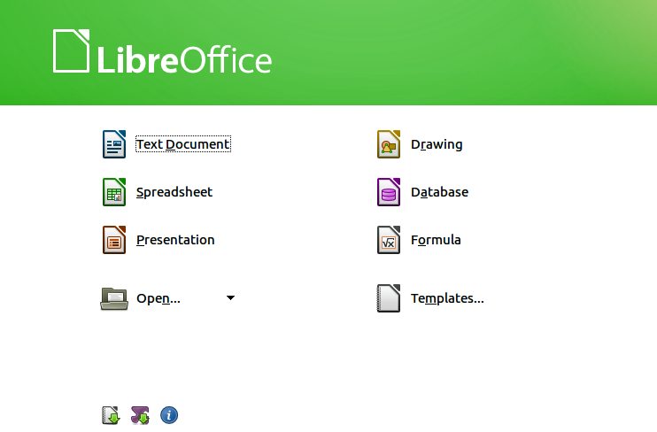
Figure 1: LibreOffice Start Center

Starting from an existing document
You can start LibreOffice by double-clicking the filename that is an ODF document in a file manager such as Windows Explorer. The appropriate component of LibreOffice will start and the document will be loaded.
If Microsoft Office is installed on your computer and you have associated Microsoft Office file types with LibreOffice, when you double-click on the file:
- For a Word file (*.doc or *.docx), it opens in Writer.
- For an Excel file (*.xls or *.xlsx), it opens in Calc.
- For a PowerPoint file (*.ppt or *.pptx), it opens in Impress.
If you did not associate the file types and Microsoft Office is installed on your computer, then when you double-click on a Microsoft Office file, it opens using the appropriate Microsoft Office component.
For more information on opening files, see “Opening existing documents” on page 14.

Quickstarter for Windows
The LibreOffice installation process installs Quickstarter on computers using the Windows operating system. Quickstarter is installed in the Windows system tray and is automatically loaded during system startup. It loads *.DLL library files required by LibreOffice, resulting in a shorter startup time for LibreOffice components. If Quickstarter has been disabled, see “Reactivating Quickstarter” on page 9 to enable it.

Using Quickstarter
Right-click the Quickstarter icon in the system tray to open a pop-up menu (Figure 2) from which you can open a new document, or open the Templates Manager, or choose an existing document to open. You can also double-click the Quickstarter icon to open the Templates Manager.
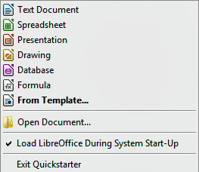
Figure 2: Quickstarter menu in Windows

Disabling Quickstarter
To close Quickstarter, right-click on the icon in the system tray, and then click Exit Quickstarter in the pop-up menu. The next time the computer is restarted, Quickstarter will be loaded again.
To prevent LibreOffice from loading Quickstarter during system startup, deselect the Load LibreOffice during system start-up item on the pop-up menu. You might want to do this if your computer has insufficient memory, for example.

Reactivating Quickstarter
If Quickstarter has been disabled, you can reactivate it by selecting the Load LibreOffice during system start-up check box in Tools > Options > LibreOffice > Memory.

Linux and Mac OS X
Computers operating Linux and Mac OS X do not have a Quickstarter module. To launch LibreOffice you have to click on the LibreOffice icon in Applications. This opens the LibreOffice startup screen (Figure 1) from where you can select the various LibreOffice components or select to open an existing file or use a template.

Parts of the main window
The main window is similar for each component of LibreOffice, although some details vary. See the relevant chapters in this guide about Writer, Calc, Draw, and Impress for descriptions of those details.
Common features include the main menu bar, standard toolbar, and formatting toolbar at the top of the window and the status bar at the bottom.

Main menu bar
The Main menu bar is located across the top of the LibreOffice window, just below the Title bar. When you select one of the menus listed below, a sub-menu drops down to show commands.
- File – contains commands that apply to the entire document such as Open, Save, and Export as PDF.
- Edit – contains commands for editing the document such as Undo: xxx (where xxx is the command to undo) and Find & Replace. It also contains commands to cut, copy, and paste selected parts of your document.
- View – contains commands for controlling the display of the document such as Zoom and Web Layout.
- Insert – contains commands for inserting elements into your document such as Header, Footer, and Picture.
- Format – contains commands, such as Styles and Formatting and AutoCorrect, for formatting the layout of your document.
- Table – contains all commands to insert and edit a table in a text document.
- Tools – contains functions such as Spelling and Grammar, Customize, and Options.
- Window – contains commands for the display window.
- Help – contains links to the LibreOffice Help file, What’s This?, and information about the program.

Toolbars
LibreOffice has two types of toolbars: docked (fixed in place) and floating. Docked toolbars can be moved to different locations or made to float, and floating toolbars can be docked.
In a default LibreOffice installation, the top docked toolbar, just under the Main menu bar, is called the Standard toolbar. It is consistent across the LibreOffice applications.
The second toolbar at the top, in a default LibreOffice installation, is the Formatting bar. It is context-sensitive; that is, it shows the tools relevant to the current position of the cursor or the object selected. For example, when the cursor is on a graphic, the Formatting bar provides tools for formatting graphics; when the cursor is in text, the tools are for formatting text.

Displaying or hiding toolbars
To display or hide toolbars, go to View > Toolbars on the main menu bar, then click on the name of a toolbar from the drop-down list. An active toolbar shows a check-mark beside its name. Toolbars created from tool palettes are not listed in the View menu.
To close a toolbar, click on the X on the right of the toolbar title or go to View > Toolbars on the main menu bar and deselect the toolbar.
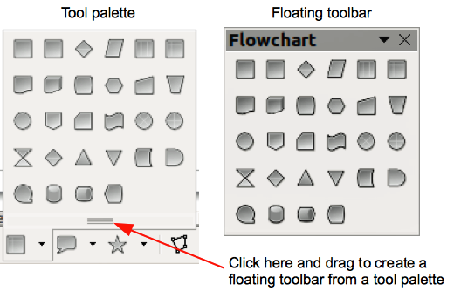
Figure 3: Example of tearing off a tool palette

Sub-menus and tool palettes
Toolbar icons with a small triangle to the right will display sub-menus, tool palettes, and other ways of selecting things, depending on the icon.
Tool palettes can be made into a floating toolbar and Figure 3 shows an example of a tool palette from the Drawing toolbar made into a floating toolbar. See “Moving toolbars” and “Floating toolbars” below for more information on moving and floating these toolbars created from tool palettes.

Moving toolbars
Docked toolbars can be undocked and moved to a new docked position or left as a floating toolbar.
- Move the mouse cursor over the toolbar handle, which is the small vertical bar to the left of a docked toolbar and highlighted in Figure 4.
- Hold down the left mouse button and drag the toolbar to the new location. The toolbar can be docked in a new position at the top, sides or bottom of the main window, or left as a floating toolbar.
- Release the mouse button.
- To move a floating toolbar, click on its title bar and drag it to a new floating location or dock the toolbar at the top or bottom of the main window.
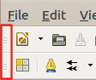
Figure 4: Toolbar handles
Note | You can also dock a floating toolbar by holding down the Ctrl key and clicking in the title bar of the toolbar.

Floating toolbars
LibreOffice includes several additional toolbars, whose default setting appear as floating toolbars in response to the current position of the cursor or selection. You can dock these toolbars to the top or bottom of the main window, or reposition them on your computer display (see “Moving toolbars” above).
Some of these additional toolbars are context sensitive and will automatically appear depending on the position of the cursor. For example, when the cursor is in a table, a Table toolbar appears, and when the cursor is in a numbered or bullet list, the Bullets and Numbering toolbar appears.

Customizing toolbars
You can customize toolbars in several ways, including choosing which icons are visible and locking the position of a docked toolbar. You can also add icons and create new toolbars, as described in Chapter 14 Customizing LibreOffice. To access the customization options for a toolbar, right-click between the icons on a toolbar. A context menu opens.
- To show or hide icons defined for the selected toolbar, click Visible Buttons. Visible icons on a toolbar are indicated by an outline around the icon (Figure 5) or by a check mark beside the icon, depending on your operating system. Select or deselect icons to hide or show them on the toolbar.
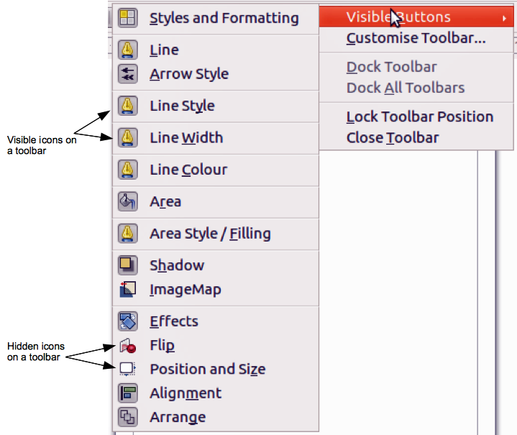
Figure 5: Selection of visible toolbar icons
- Click Customise Toolbar to open the Customise dialog, see Chapter 14 Customizing LibreOffice for more information.
- Click Dock Toolbar to dock the selected toolbar. By default, a toolbar will dock at the top of the workspace. You can reposition the toolbar to a different docked position, see “Moving toolbars” on page 11.
- Click Dock All Toolbars to dock all floating toolbars. By default, toolbars will dock at the top of the workspace. You can reposition the toolbars to different docked positions, see “Moving toolbars” on page 11.
- Click Lock Toolbar Position to lock a docked toolbar into its docked position.
- Click Close Toolbar to close the selected toolbar.

Docking/floating dialogs
When dialogs open, they are floating dialogs, unless they have been docked when LibreOffice was last opened. These floating dialogs can be docked by holding down the Ctrl key and double-clicking in a vacant area near the icons at the top of the floating dialog. The dialog will then dock in its last docked position on the workspace. After docking, you can resize the docked dialog and reposition in a new docked position.
To undock a docked dialog and make it floating, hold down the Ctrl key and double-click in a vacant area near the icons at the top of the docked dialog. Alternatively, click and hold in a vacant area near the icons at the top of the docked dialog and drag it to a floating position.

Context menus
Context menus are a quick access to many menu functions and are opened by right-clicking on a paragraph, graphic, or other object. When a context menu opens, the functions or options available will be dependent on the object that has been selected. A context menu can be the easiest way to reach a function, especially if you are not sure where a function is located in the menus or toolbars.

Status bar
The status bar is located at the bottom of the workspace. It provides information about the document and convenient ways to quickly change some features. It is similar in Writer, Calc, Impress, and Draw, but each LibreOffice component includes some component-specific items. An example of the Writer status bar is shown in Figure 6.
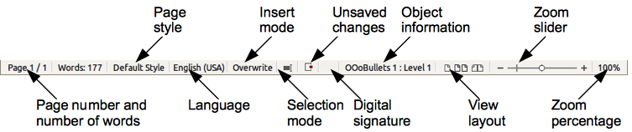
Figure 6: Example status bar from Writer
Page, sheet, or slide number
Shows the current page, sheet, or slide number and the total number of pages and words, sheets, or slides in the document. Double-click on this field to open the Navigator. Other uses of this field depend on the LibreOffice component.
Page style or slide design
Shows the current page style or slide design. To edit the current page style or slide design, double-click on this field.
Language
Shows the current language of the whole document.
Insert mode
Shows the type of insert mode the program is in. This field is blank if the program is in Insert mode. Press the Ins key to change modes.
Unsaved changes
An icon appears here if changes to the document have not been saved.
Digital signature
If the document has been digitally signed, an icon shows here. You can double-click the icon to view the certificate.
Object information
Displays information relevant to the position of the cursor or the selected element of the document. Double-clicking in this area usually opens a relevant dialog.
Zoom slider and percent
Drag the Zoom slider, or click on the + and – signs to change the view magnification.
Zoom percentage
Indicates the magnification level of the document. Right-click on the percentage figure to open a list of magnification values from which to choose. Double-clicking on this percentage figure opens the Zoom & View Layout dialog.

Starting new documents
You can start a new, blank document in LibreOffice in several ways.
When LibreOffice is open but no document is open, the Start Centre (Figure 1 on page 8) is shown. Click one of the icons to open a new document of that type, or click the Templates icon to start a new document using a template.
You can also start a new document in one of the following ways:
- Use File > New on the main menu bar and select the type of document from the context menu.
- Use Ctrl+N on the keyboard to start a new text document.
- Use File > Wizards on the main menu bar and select the type of document from the context menu.
- If a document is already open in LibreOffice, click the New icon on the Standard toolbar and a new document of the same type opens in a new window. For example, if Calc is open, a new spreadsheet is opened. The New icon changes depending on which component of LibreOffice is open.
Note | If all documents are closed without closing LibreOffice, then the Start Centre will be displayed.

Opening existing documents
You can also open an existing document in one of the following ways:
- When no document is open, click the Open icon on the Start Centre and select from a list of available documents.
- Click the small triangle to the right of the Open icon and select from a list of recently opened documents.
- Go to File > Open on the main menu bar
- Click the Open icon on the Standard toolbar if there is a document already open.
- Press Control+O on the keyboard.
In each case above, an Open dialog opens. Navigate to the folder you want and select the file you want, and then click Open. If a document is already open in LibreOffice, the second document opens in a new window.
In the Open dialog, you can reduce the list of files by selecting the type of file you are looking for. For example, if you choose Text documents as the file type, you will only see documents Writer can open (including... .odt, .doc, .txt); if you choose Spreadsheets, you will see .ods, .xls, and other files that Calc opens.
You can also open an existing document that is in a format that LibreOffice recognizes by double-clicking on the file icon on the desktop or in a file manager such as Windows Explorer. LibreOffice has to be associated with file types that are not ODF files for the appropriate LibreOffice component to open.
Note | On computers operating Microsoft Windows or Mac OS X, you can select to use the LibreOffice Open/Save dialogs or the ones provided by the computer operating system. See “Open and Save As dialogs” on page 18 for more information.

Saving documents
You can save documents as follows:
- Using the Save command if you are keeping the document, its current filename and location.
- Using the Save As command if you want to create a new document, or change the filename and/or file format, or save the file in a different location on your computer.
- Using password protection if you want to restrict who can open and read the document, or open and edit the document.

Save command
To save a document if you are keeping the document, its current filename and location, do one of the following:
- Use the keyboard shortcut Ctrl+S.
- Go to File > Save on the main menu bar.
- Click the Save icon on the standard toolbar.
Using the Save command will overwrite the last saved version of the file.

Save As command
To save a document if you want to create a new document, or change the filename and/or file format, or save the file in a different location on your computer:
- Use the keyboard shortcut Ctrl+Shift+S.
- Go to File > Save As on the main menu bar.
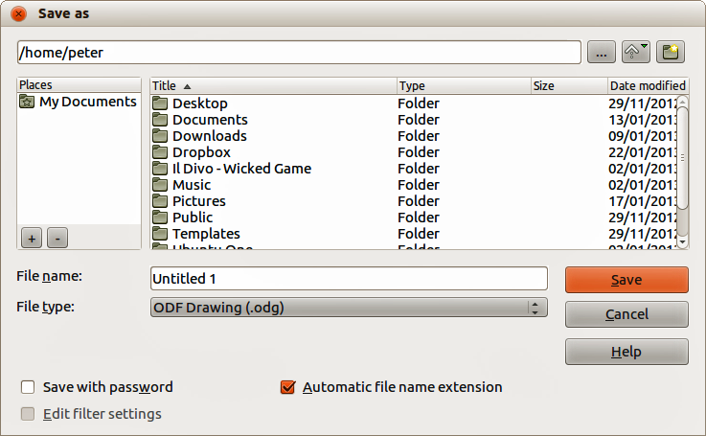
Figure 7: Example of LibreOffice Save As dialog
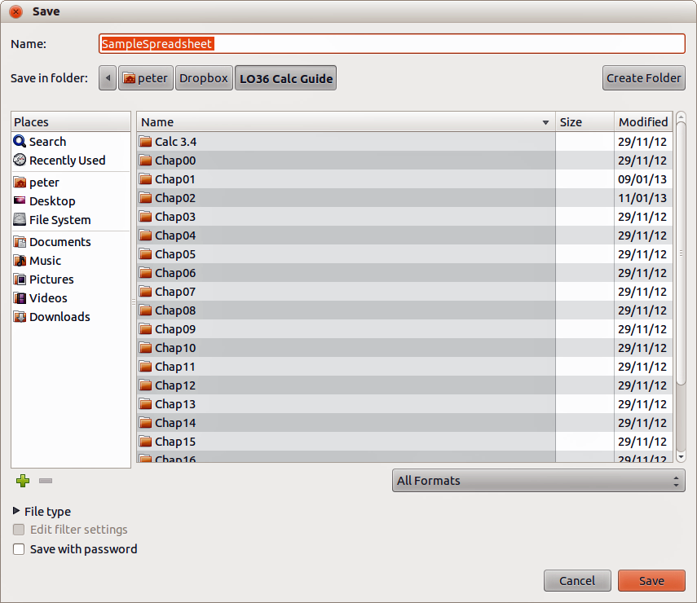
Figure 8: Example of an operating system Save dialog
When the Save As dialog (Figure 7) or Save dialog (Figure 8) opens, enter the file name, change the file format (if applicable), navigate to a new location (if applicable), and click Save.
The dialog that opens when using the Save As command depends on the options that have been set in LibreOffice. See “Open and Save As dialogs” on page 18 for more information.

Password protection
To protect a document and restrict who can open and read the document, or open and edit the document, you have to use password protection.
- Using the Save As command above, select the Save with password option in the Save As dialog or Save dialog.
- Click Save and the Set Password dialog opens (Figure 9).
- In File encryption password, enter a password to open the document and then enter the same password as confirmation.
- To restrict who can edit the document, click the More Options button. This button changes to Fewer Options when clicked.
- In File sharing password, select Open file read only and enter a password to allow editing and then enter the same password as confirmation.
- Click OK and the dialog closes. If the passwords match, the document is saved password protected. If the passwords do not match, you receive an error message.
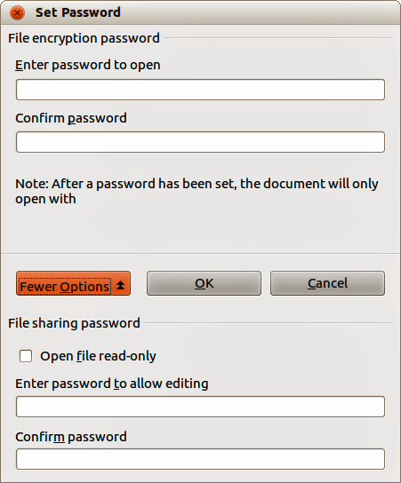
Figure 9: Set Password dialog
Caution   | LibreOffice uses a very strong encryption mechanism that makes it almost impossible to recover the contents of a document if you lose or forget the password.

Changing password
When a document is password-protected, you can change the password while the document is open. Go to File > Properties > General on the main menu bar and click the Change Password button in the Properties dialog. This opens the Set Password dialog where you can enter a new password.

Saving documents automatically
LibreOffice can save files automatically, which is part of the AutoRecovery feature included in LibreOffice. Automatic saving, like manual saving, overwrites the last saved state of the file. To set up automatic file saving:
- Go to Tools > Options > Load/Save > General on the main menu bar.
- Select Save AutoRecovery information every and set the time interval.
- Click OK.

Renaming and deleting files
You can rename or delete files within the LibreOffice dialogs, just as you can in a file manager. Select a file and then right click to open a context menu. Select either Delete or Rename, as appropriate. However, you cannot copy or paste files within the dialogs.

Open and Save As dialogs
You can choose whether to use the LibreOffice Open and Save As dialogs or the ones provided by your operating system.
- To use LibreOffice dialogs for saving or opening files, go to Tools > Options > LibreOffice > General and check the option Use LibreOffice dialog boxes. An example of a LibreOffice dialog is shown in Figure 7 on page 15.
- To use the operating system dialogs for saving or opening files, go to Tools > Options > LibreOffice > General and uncheck the option Use LibreOffice dialog boxes. An example of an operating system dialog is shown in Figure 8 on page 16.
The three icons in the top right of the LibreOffice Open and Save As dialogs are as follows:
- Connect To Server – a dialog opens allowing you to connect to a network server if the file you want is not located on your computer.
- Up One Level – moves up one folder in the folder hierarchy. Click and hold the mouse button on this icon to display a drop down a list of higher level folders. Move the cursor over a higher level folder and release the mouse button to navigate to that folder
- Create New Folder – creates a new sub-folder in the folder that is displayed in the dialog.
Use the File type field to specify the type of file to be opened or the format of the file to be saved.
The Read-only option on the Open dialog opens the file for reading and printing only. Most of the icons and most menu options are disabled on the toolbars. The Edit File icon becomes active on the Standard toolbar. Click on this icon to open the file for editing.

Using the Navigator
The LibreOffice Navigator lists objects contained within a document, collected into categories. For example, in Writer it shows Headings, Tables, Text frames, Comments, Graphics, Bookmarks, and other items, as shown in Figure 10. In Calc it shows Sheets, Range Names, Database Ranges, Graphics, Drawing Objects, and other items. In Impress and Draw it shows Slides, Pictures, and other items. An example of the Navigator used in Calc is shown in Figure 10.
To open the Navigator, click the Navigator icon on the Standard toolbar, or press the F5 key, or go to View > Navigator on the main menu bar.
You can dock the Navigator to either side of the main LibreOffice window or leave it floating (see “Docking/floating dialogs“ on page 12 for more information).
Click the marker (+ or triangle) by any of the categories to display the list of objects in that category.
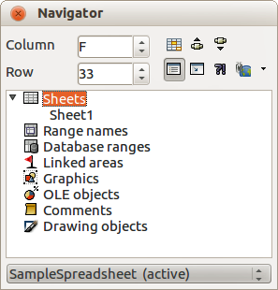
Figure 10: Navigator in Calc
The Navigator provides several convenient ways to move around a document and find items in it:
- When a category is showing the list of objects in it, double-click on an object to jump directly to that object location in the document.
- Objects are much easier to find if you have given them recognisable names when creating them, instead of keeping the LibreOffice default names, for example Sheet1, Table1, Table2, and so on. The default names may not correspond to the actual position of the object in the document.
- Each Navigator in the individual LibreOffice components has a different range of functions and these functions are further explained in the appropriate user guides for each LibreOffice component.

Undoing and redoing changes
To undo the most recent change in a document, use the keyboard shortcut Ctrl+Z, or click the Undo icon on the Standard toolbar, or go to Edit > Undo on the main menu bar. Click the small triangle to the right of the Undo icon to get a list of all the changes that can be undone. You can select multiple changes and undo them at the same time.
After changes have been undone, you can redo changes. To redo a change use the keyboard shortcut Ctrl+Y, or click the Redo icon , or go to Edit > Redo on the main menu bar. As with Undo, click on the triangle to the right of the arrow to get a list of the changes that can be reapplied.
To modify the number of changes LibreOffice remembers, go to Tools > Options > LibreOffice > Memory on the main menu bar. In the Undo section increase or decrease the Number of steps. Be aware that asking LibreOffice to remember more changes consumes more computer memory.

Closing a document
If there is only one document open and you want to close the document, go to File > Close on the menu bar or click on the X on the menu bar.
If more than one document is open, go to File > Close on the menu bar or click on the X on the title bar of the window. The X may be located on either the right or left end of the title bar. When the last document is open, the X on the menu bar appears.
If the document has not been saved since the last change, a message box is displayed. Choose whether to save or discard your changes.
Caution | Not saving your document could result in the loss of recently made changes, or worse still, your entire file.

Closing LibreOffice
To close LibreOffice completely, go to File > Exit on the Menu bar in Windows and Linux operating systems. In a Mac operating system, go to LibreOffice > Quit LibreOffice on the menu bar.
When you close the last document using the X on the title bar of the window, then LibreOffice will close completely. A Mac operating system does not have this function; instead, you need to go to LibreOffice > Quit LibreOffice on the menu bar.
You can also use a keyboard shortcut as follows:
- In Windows and Linux – Ctrl+Q
- In Mac OS X – Command +Q
If any documents have not been saved since the last change, a message box is displayed. Choose whether to save or discard your changes.

